# Media Analysis - AI is not smarter than humans _ Updated 08 April 2023

## Short Summary

The article is about how AI can be a useful tool to aid humans in various tasks, but it still has limitations and will never be able to replace human connection and creativity.

## Summary

Here are 4 bullet points summarizing the text:  
  
• The author is an advocate for AI tools, citing their potential to enrich personal life and aid business tasks.  
• Despite its capabilities, AI cannot replace human connection or capture the complexity of cultural nuances, as demonstrated by its inability to convey meaningful feelings through technology alone.  
• The author notes that AI can help simplify workloads and provide innovative ideas, but it is still in its infancy and requires careful development and use.  
• With advancements in technology, AI has become increasingly prevalent in our lives, raising questions about its future impact on society and how it will shape human relationships.

## Question 1

The text frames the public discussion about AI as a tool that can enrich personal life and aid in business tasks, but also acknowledges its limitations. Metaphors used include * AI being compared to a virtual assistant or a person who can help with tasks * Chatbots being referred to as having personality * The author mentions that AI is still in its infancy, implying that it s not yet fully developed. * A warning about the potential for AI to be corrupted by negative input, like the example of Tay. These metaphors suggest a mix of enthusiasm and caution regarding the capabilities and limitations of AI.

## Question 2

Based on the text, the following perspectives and aspects are being widely covered * **Positive views** AI as a tool for personal life enrichment, aiding business tasks, and simplifying workloads. * **Enthusiasm** The author is an advocate for AI tools and appreciates their capabilities. * **Potential impact on marketing and business** AI s ability to aid in marketing campaigns, generate ideas, and assist with tasks like writing letters and resumes. Aspects being ignored or not widely covered * **Negative consequences of AI** While the author mentions Tay s corruption, this is presented as a cautionary example rather than a comprehensive exploration of potential risks. * **Dependence on English language** The text highlights the dominance of English in communicating with AI, but does not discuss the limitations and challenges posed by this situation for non-English speakers. * **Impact on human relationships** While the author acknowledges that AI cannot replace human connection, this is a relatively minor point compared to the overall emphasis on AI s benefits.

## Question 3

Not mentioned

## Question 4

The final message of the article is that AI can aid and simplify human tasks, but it will never replace the essential human connection and personal touch.

## Sentiment

The sentiment is 3.0

## Entities

Oracle, Twitter, Saint Marys University, Google Translate, SAP, Apple, Ali Al-Mustafa, Tay, Saleh, Microsoft

## Highlights

#7cc867: 29

#fb5b89: 29

#f9cd59: 19

## Wordcloud for #7cc867 Highlights

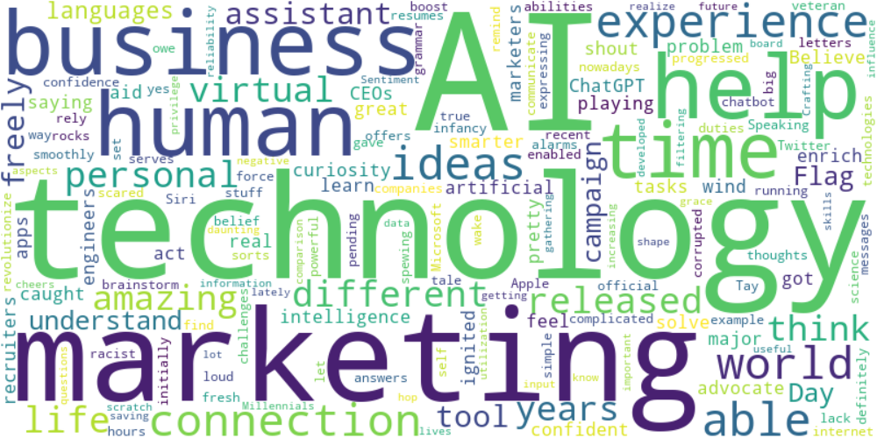

Top 10 words:

- AI: 10

- technology: 8

- marketing: 6

- like: 5

- business: 4

- humans: 3

- experience: 3

- able: 3

- ideas: 3

- connection: 3

## Wordcloud for #fb5b89 Highlights

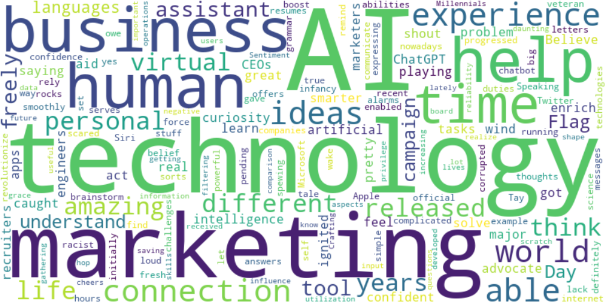

Top 10 words:

- AI: 10

- technology: 8

- marketing: 6

- like: 5

- business: 4

- humans: 3

- experience: 3

- able: 3

- ideas: 3

- connection: 3

## Wordcloud for #f9cd59 Highlights

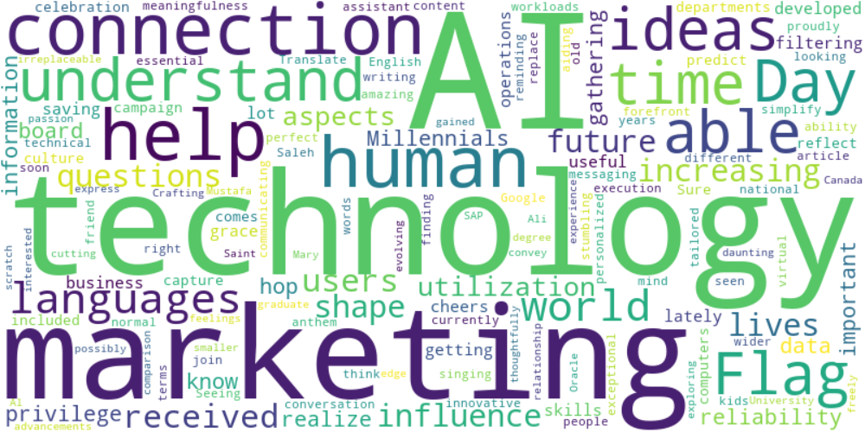

Top 10 words:

- AI: 6

- technology: 5

- marketing: 4

- connection: 3

- help: 3

- like: 2

- humans: 2

- understand: 2

- able: 2

- ideas: 2